
Final Project Report

Quiz game with multiple questions and answers

Title Page

PROJECT REPORT
Quiz Game: Develop a quiz game with multiple questions and answers.

Submitted by: Submitted to:
Name: Nitin Raj Teacher’s Name: Mr. Jagvinder Singh
UID: 25BCA10383 Subject Name: Web designing
Subject Code: 25CAH - 153 Course: BCA
Date of submission: 16th April 2026

 Abstract 

The Quiz Master – Interactive Trivia Challenge is a web-based application developed using HTML, CSS, and JavaScript. The project is designed to provide users with an engaging platform to test their knowledge through multiple-choice questions. It offers a dynamic and responsive interface where users can answer questions, receive instant feedback, and view their final score at the end of the quiz.
The system focuses on simplicity, usability, and interactivity. It enhances learning by providing immediate feedback and encourages users to improve their knowledge through repeated attempts. The application uses JavaScript for dynamic content rendering and state management, while CSS ensures an attractive user interface.
This project demonstrates fundamental web development concepts such as DOM manipulation, event handling, and responsive design.


Introduction

With the rapid growth of digital learning, online quiz systems have become an essential tool for education and self-assessment. Traditional learning methods often lack interactivity, which reduces user engagement. The Quiz Master application addresses this issue by providing an interactive environment for learning and evaluation.
This project is a browser-based quiz system that allows users to:
- Attempt multiple-choice questions
- Get instant feedback
- Track their score
- Restart and replay the quiz
The application is lightweight, does not require installation, and runs directly in a web browser. It is suitable for students, teachers, and anyone interested in testing their knowledge in a fun and interactive way.


Aim / Objectives

- Aim

The main aim of this project is to develop an interactive and user-friendly web-based quiz application that allows users to test their knowledge, receive instant feedback, and improve learning through an engaging interface.

Objectives
- To design a simple and attractive user interface for better user experience
- To develop a responsive quiz system that works on both mobile and desktop devices
- To implement multiple-choice questions with clear options
- To provide instant feedback after each answer selection
- To calculate and display the user’s score accurately
- To enable users to navigate through questions smoothly
- To add a restart option for reattempting the quiz
- To ensure fast performance and smooth execution using JavaScript
- To enhance user engagement through interactive design and animations
- To build a system that can be easily upgraded with new features in the future


- Scope of the Project

- The project focuses on developing a web-based quiz application accessible through a browser
- It allows users to attempt multiple-choice questions interactively
- The system provides instant feedback after each answer
- It includes real-time score calculation and display
- The application is designed to be responsive, working on both mobile and desktop devices
- It ensures a simple and user-friendly interface for easy navigation
- Users can restart the quiz and attempt it multiple times
- The quiz data is stored locally in the code using JavaScript arrays
- The project demonstrates basic concepts of HTML, CSS, and JavaScript integration
- It can be used for educational purposes and self-assessment

- Problem Statement
- Traditional quiz systems are not interactive and often feel boring for users
- Many existing systems do not provide instant feedback, making learning less effective
- Lack of user-friendly interfaces makes it difficult for beginners to use quiz platforms
- Most quizzes are static and do not update dynamically based on user interaction
- There is no proper system to track user performance in real-time
- Many platforms are not responsive, so they do not work well on mobile devices
- Users cannot easily restart or retry quizzes to improve their performance
- Existing systems often lack engaging design and visual appeal
- There is a need for a simple, lightweight, and browser-based solution that does not require installation
- A system is required that can combine learning with interaction and fun

- Technology Used
HTML (Hyper Text Markup Language)
- Used to create the structure of the web page
- Defines elements like headings, buttons, and quiz layout
CSS (Cascading Style Sheets)
- Used for styling and designing the application
- Adds colours, layouts, fonts, and responsiveness
- Makes the interface attractive and user-friendly
JavaScript
- Used to implement the logic of the quiz system
- Handles question display, answer checking, and score calculation
- Enables dynamic content and interactivity


DOM (Document Object Model)
- Used to manipulate HTML elements dynamically
- Updates questions, options, and feedback in real-time
Web Browser (Chrome, Edge, etc.)
- Used to run and test the application

- System Requirements
Hardware Requirements

- Computer / Laptop / Smartphone
- Minimum 2GB RAM
- Software Requirements:

- Web Browser (Chrome, Edge, Firefox)
- Code Editor (VS Code )
- System Design
Modules in the Project

- User Interface (UI) Module
  - Responsible for displaying the quiz layout
  - Shows questions and answer options
  - Displays score and question number
  - Provides buttons like Next and Restart


- Question Management Module
• Stores all quiz questions in a JavaScript array
• Contains:
- Question text
- Options
- Correct answer
• Supplies questions one by one to the UI
• Ensures proper sequence of questions
- Quiz Logic Module
Controls the overall flow of the quiz
Manages:
  - Current question index
  - Quiz progress
Decides when to move to next question or end quiz
Ensures smooth navigation and execution

- Answer Validation Module
Checks whether the selected answer is correct or wrong
Compares user input with correct answer index
Highlights
Correct answer
Wrong answer

- Score Management Module

Calculates the user’s score
Increases score for correct answers
Keeps track of total marks
Displays score in real-time

❖ Limitations
- Limited questions
- No database
- No login system
- No leaderboard
- No timer
- Static content
- No difficulty levels
- No multiplayer

❖ Software Requirements
- HTML5
- CSS3
- JavaScript
- VS Code
- Web Browser

❖ Testing
- Functional Testing
- UI Testing
- Usability Testing
- Performance Testing


❖ Features of the Project
- Provides an interactive quiz interface for users
- Displays multiple-choice questions (MCQs)
- Shows four options for each question
- Allows users to select answers easily
- Gives instant feedback (correct or wrong)
- Highlights the correct answer after selection
- Calculates and displays score in real-time
- Shows current question number and total questions
- Includes a Next button to move to the next question
- Displays a final result screen after quiz completion
- Shows percentage score and performance message
- Provides restart option to attempt quiz again

❖ Advantages of the Project
- Provides an interactive and engaging learning experience
- Helps users test and improve their knowledge
- Gives instant feedback, improving understanding
- Simple and easy-to-use interface for all users
- Works on multiple devices (mobile, tablet, desktop)
- No installation required — runs directly in a web browser

 CODE

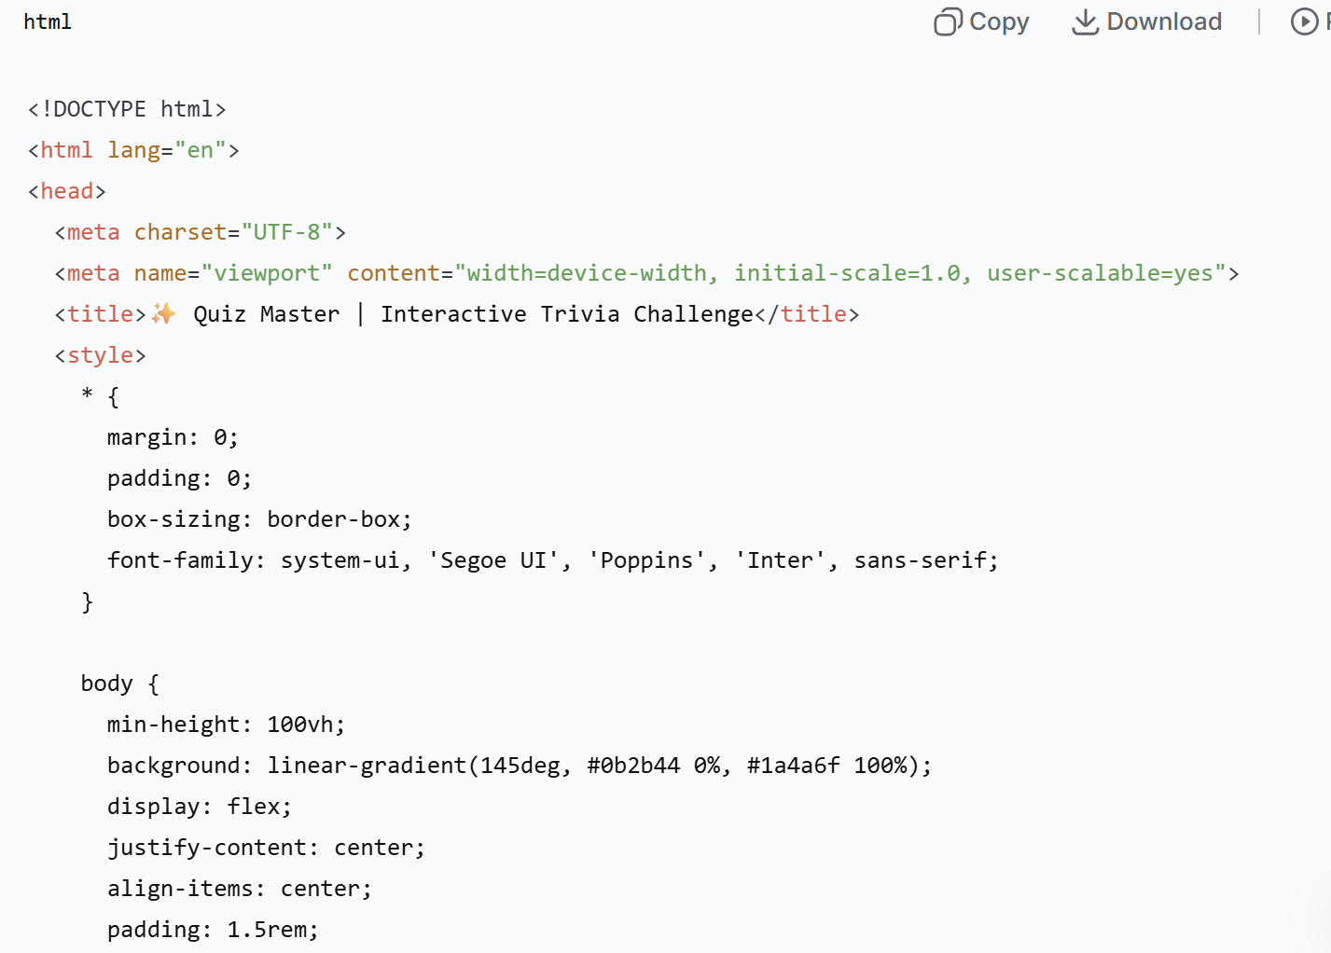

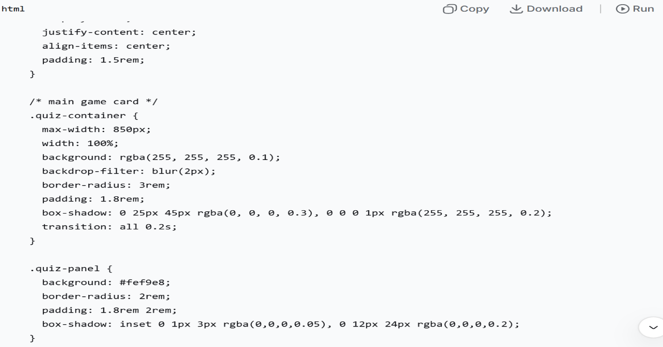

 OUTPUT 

Without Play
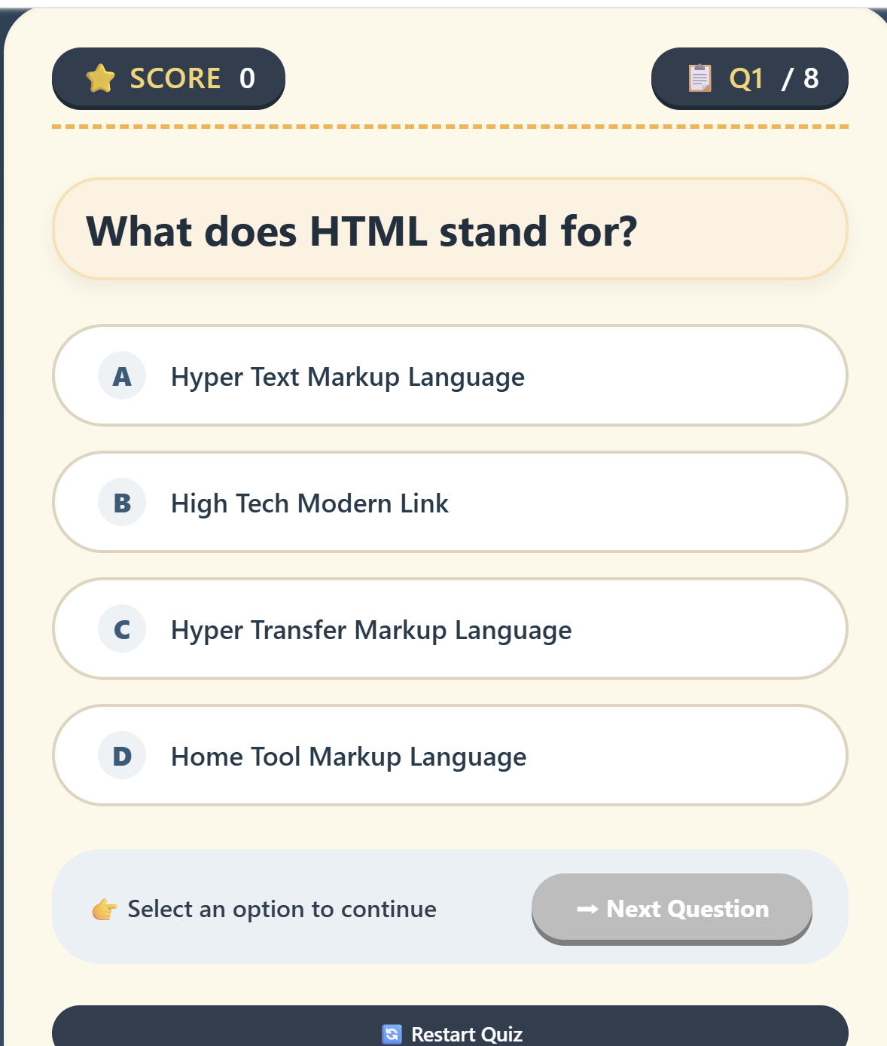

Output
After Play
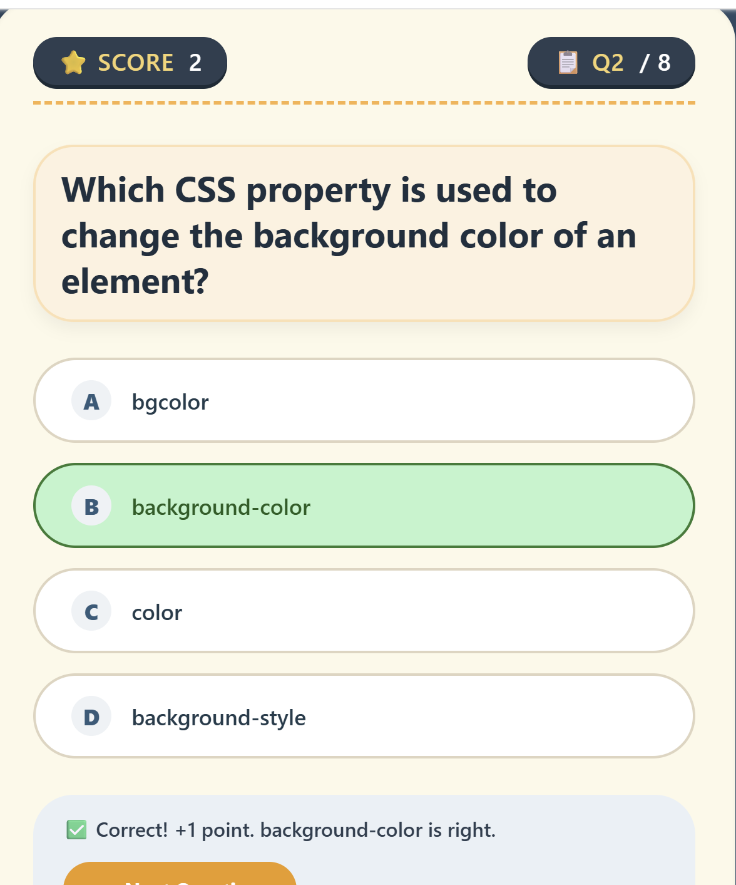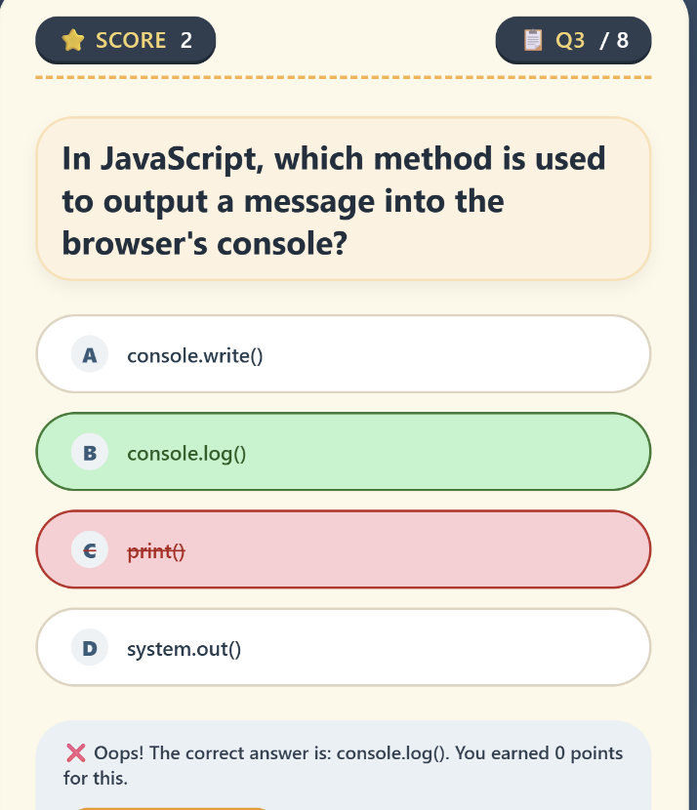


❖ Limitations
- Limited questions
- No database
- No login system
- No leaderboard
- No timer
- Static content
- No difficulty levels
- No multiplayer

❖ Testing
- Functional Testing
- UI Testing
- Usability Testing
- Performance Testing

❖ Conclusion
The Quiz Master project successfully demonstrates the development of an interactive and user-friendly web-based quiz application using HTML, CSS, and JavaScript. It provides an engaging platform for users to test their knowledge, receive instant feedback, and track their performance through real-time scoring. The project meets its objectives by offering a simple interface, smooth navigation, and responsive design. Overall, it serves as an effective learning tool and a strong foundation for future enhancements such as database integration and advanced features.

❖ Future Enhancements
- Add a large set of questions to increase quiz variety
- Introduce multiple categories (Science, Sports, History, etc.)
- Implement a timer for each question
- Add user login and registration system
- Develop a leaderboard to compare scores
- Integrate a database (MySQL/Firebase) to store results

